Study Protocol

Analysis of health benefits of olive leaf extract using in vivo transcriptomic profiling

Investigator:
Lynnette Ferguson
Discipline of Nutrition
Faculty of Medical and Health Sciences,
The University of Auckland
Private Bag 92019

Tel: (09) 923 6372
Email: l.fergusonauckland.ac.nz

Gene expression
There is limited research that has investigated the health benefits of Olive leaf extract for human consumption in vitro. The limited human in vitro and animal studies have indicated the health benefits are due to an interaction of its nutrients and minor components with genes, thus influencing their expression. There is a wider literature base for the effects of olive oil (OO) and it is hypothesised that many of the health benefits are a result of the polyphenols. These polyphenols are far more concentrated in the leaves of olive trees. Reports have indicated that the olive polyphenols may modulate gene expression and regulation of eNOS protein, resulting in vasorelaxation in hypertensive rats (Rodriguez-Rodriguez et al., 2007). This has been supported by recent work that has shown improved blood pressure in hypertensive males with olive leaf extract (Lockyer, thesis to be published). Other studies with OLE in cell line, animal and human trials have focused on insulin sensitivity (de Bock et al. 2013), obesity attenuation (Shen et al. 2013), immune response (Samet et al. 2014) or inflammation (Liu et al. 2014), with related genes regulated.

The work on OLE has focussed on specific outcomes or biomarkers such as IL-8 or CRP and there is a lack of human trials looking at the wider scope. By running a wide gene expression profile after olive leaf extract consumption in humans we can understand what gene expressions are changed in relation to other genes. The genetic pathways and relationships can be used to understand the modes of action and the different health benefits provided by OLE.

Justification for Pilot Intervention Trial
A broad literature offers circumstantial and empirical support for the contention that olive leaf extract consumption has a variety of potential health benefits in a range of experiments. Many of these health benefits relate to heart disease, immune function and diabetes looking at the following parameters: blood lipids, blood pressure, inflammatory markers and insulin sensitivity. These studies all have a premeditated hypothesis that is tested by looking at specific biomarkers or other measures; they fail to look at the inclusive change. The many health benefits are a likely result of genetic changes that take place. These changes can be monitored in peripheral blood mononuclear cells. Therefore by looking at a human wide gene regulation we can understand the molecular level health benefits and their function.

The study will use changes in a gene expression in peripheral blood mononuclear cells (PBMC) to measure the effects of OLE. RNA will be extracted from the tissue and hybridised onto Affymetrix arrays. Validated software will be used to create a gene expression profile of functional clusters of genes that are perturbed by the dietary intervention. Subsequent analysis of selected genes by RT-PCR will confirm any significant changes in gene expression.

OBJECTIVES
- To compare changes in gene expression, following a 8 week intervention of either Olive Leaf extract or placebo intervention in healthy human volunteers
- To determine the exercise and dietary trends of individuals and relate them to observed changes in gene expression.

Figure 1. Study Design.
ROLLING RECRUITMENT
30 volunteers recruited by standard means. Information sheets and letters of invitation given to volunteers

INFORMATION EXCHANGE
Interested volunteers will be referred to study scientist at UofA and invited to attend an interview at the Nutrition department or a designated place for initial information exchange

Visit 1: Screening visit
Interested volunteers will receive an information pack consisting of information sheet, consent form, related questionnaires, fecal test tubes and 3-day food and activity recording sheets. They will email/ hand in the, signed informed consent, questionnaires and diet and activity diaries to the study centre. They will be given specific instructions in recording 3-day food intake and activities. Once these documents are received they will be registered in the study and given a study code number.

VISIT 2: DIETARY AND HEALTH ASSESSMENT 1
Volunteers will be randomly placed into either the OLE or placebo arm of the study. Both groups will be invited to the study centre and requested to provide blood sample and bring with them a fecal sample
Volunteers will receive the treatment/placebo oil for the 8 weeks.

Group Allocation

Olive leaf extract group
15 volunteers

Placebo group
15 volunteers

DIETARY INTERVENTION (with support for 8 weeks)
DIETARY ASSESSMENT 2
3 day food intake and activity diary completion at approximately 8 weeks

VISIT 3: CLINIC APPOINTMENT (at 8 weeks)
A blood sample and fecal sample will be collected at 8 weeks. Submission of diet and activity diaries recorded at 8 weeks.

Olive Leaf extract and Placebo Ingredients
The Olive leaf extract will be compared to a placebo supplement that does not contain any of the active ingredients. A 15ml dose will be consumed with food twice a day. The placebo will contain ingredients that will be similar to the OLE bitter flavour.
Olive Leaf extract, Comvita
- Vegetable glycerol (bulking agent)
- and Olea europaea (Olive) Leaf extract (water, olive leaf solids) equivalent to 7.5g

Placebo
- 30L Sucrose octa acetate
- 98g Caramel colour
- 0.9g Damascenone
- 0.075g Guaiacol
- 0.075g Eugenol

Recruitment Policy
Potential volunteers, male, aged 20-70 years will be identified and recruited from the wider community. Following a verbal expression of interest in the study, they will be sent a letter (annex 1) inviting potential volunteers to take part in the study together with a volunteer information sheet (annex 2), and consent form. Interested volunteers will be requested to send in their duly signed consent and questionnaires to the study centre. The receipt of documentation will be considered as visit 1 time point.

Dietary Assessment 1
We wish to measure diet and activity profile in all participants. The diet and activity profile will be measured using the UofA standard 3-day food and activity diary to make estimations. Volunteers will be asked to include use of any dietary supplements or herbal treatments in the diary.

Therefore, volunteers that have given consent to the study will be instructed to record their intake of food, beverages and supplements consumed over a 3-day period (incorporating 3 different days, including 1 weekend day) using household measures as an indication of portion size. They will be also asked to fill in the activity profile. Details of how to complete the diary are given in annex 6 along with an example diary. Volunteers will return these diaries to UofA at the clinical visits. Contact details of the investigators and OLE suppliers will be provided to all potential volunteers.

Volunteer recruitment will continue until a maximum of 30 individuals have completed the required documentation and sent them to the study centre.

Consent and Baseline Blood Sample Visit 2
All volunteers responding positively following the period of consideration will be invited to the Nutrition Department for the visit 2. The study scientist will go through the consent form with the volunteer and encourage any questions they may have at this stage; after which the volunteer will sign the consent form agreeing to participate in the study if this has not been done previously. Copies of the consent form will be kept in the study records, and a copy given to the volunteer to keep.

Measurements of patient’s height and weight will be made at this stage. A qualified phlebotomist will take a 10-15 ml blood sample. The blood sample will be required in order to extract RNA and create gene regulation measurements. A fecal sample will be brought to the appointment. This will be immediately frozen and stored.

Once recruited onto the study, volunteers will be assigned a code, only the study scientists approved by the Ethics Committee being able to link codes to volunteers. All personal information will be kept confidential and known only to the Principle Investigators.

Dietary Assessment 2
We wish to measure diet and lifestyle in both OLE and placebo groups. This will be measured using the UofA standard 3-day food and activity diary that will be administered at 8 weeks in to the study.

Volunteers will be reminded to record their intake of food, beverages and any dietary supplements or herbal treatments consumed over a 3-day period (incorporating 2 week days, and one day from a weekend) using household measures as an indication of portion size. Details of how to complete the diary are given in annex 6 along with an example diary.

Visit 3
Patients will be invited to the study centre at 8 weeks at which time they will submit their dietary assessment 2 records to the study coordinator. They will provide a blood, sample and fecal sample as defined at visit 2.
Measurements of patient’s height and weight will be made.

Compliance
The food intake diaries collected at both time points will be analysed using Foodworks Professional 1998-2012 Xyris software and the New Zealand food composition tables.

This is intended to aid compliance of the dietary interventions and also to be used in comparison with metabolomic measures of compliance. Volunteers from both intervention arms will be telephoned fortnightly by a member of the study team to monitor progress.

Sample size and Statistical Analysis
Transcriptomics studies with Olive Leaf Extract are very limited. Previous work on OLE has focused on inflammatory markers; IL-6 and IL-8 have shown significant expression changes in a range of literature. De Bock et al. 2013 and Lockyer, 2014 using the Olive Leaf Extract (Comvita) found significant changes in IL-6 and IL-8 regulation. Standard deviations were used to calculate a sample size that would be able to produce this significant change in expression. This is a pilot study.

Sample Collection
Blood samples will be collected at the study clinic by a registered phlebotamist. The plan for sample collection is detailed below.

Blood Samples
A 10-15ml-blood sample will be collected at baseline for RNA extraction to determine gene regulation. The blood sample will be taken at the Faculty of Medical and Health Sciences, Grafton campus, The University of Auckland. RNA will be extracted at The University of Auckland, Grafton campus. Further 10-15ml blood samples will be collected during the second visit to the study centre (at 8 weeks) by a qualified phlebotomist. The samples will be immediately processed to purify RNA for the Affymetrix array and RT-PCR.

Blood not used in the Affymetrix will be kept for future study of the supplement or if time permits within this project for PBMC phagocytosis analysis.

Fecal samples
A fecal sample will be brought into the University Campus in provided plastic vials by the volunteers for visit 2 and 3 (baseline and completion if the intervention). This will be stored at The University of Auckland, Grafton campus for future studies.

Figure 2 Plan of sample collection

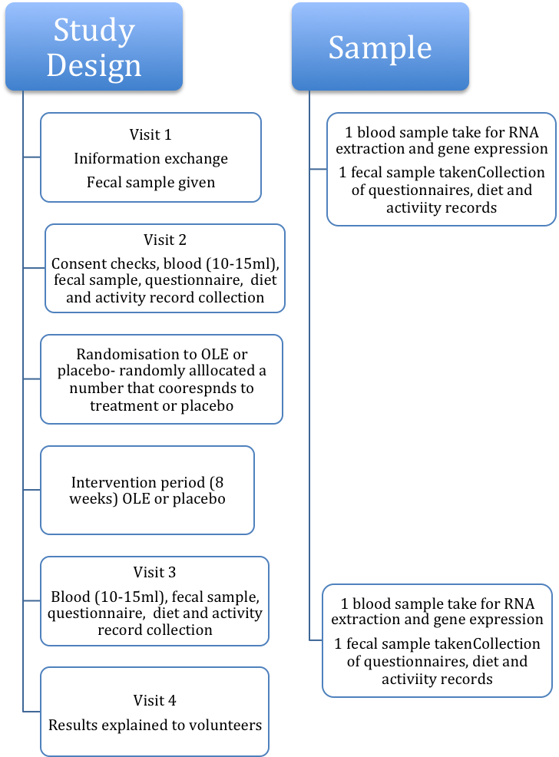

References

De Bock, M., Derraik, J. G. B., Brennan, C. M., Biggs, J. B., Morgan, P. E., Hodgkinson, S. C., … Cutfield, W. S. (2013). Olive (Olea europaea L.) leaf polyphenols improve insulin sensitivity in middle-aged overweight men: a randomized, placebo-controlled, crossover trial. PloS one, 8(3), e57622. doi:10.1371/journal.pone.0057622
Liu, Y.-N., Jung, J.-H., Park, H., & Kim, H. (2014). Olive leaf extract suppresses messenger RNA expression of proinflammatory cytokines and enhances insulin receptor substrate 1 expression in the rats with streptozotocin and high-fat diet–induced diabetes. Nutrition Research, 1–8. doi:10.1016/j.nutres.2014.04.007
Rodriguez-Rodriguez, R., Herrera, M. D., de Sotomayor, M. A., & Ruiz-Gutierrez, V. (2007). Pomace Olive Oil Improves Endothelial Function in Spontaneously Hypertensive Rats by Increasing Endothelial Nitric Oxide Synthase Expression*. American journal of hypertension, 20(7), 728-734.
Samet, I., Han, J., Jlaiel, L., Sayadi, S., & Isoda, H. (2014). Olive (Olea europaea) Leaf Extract Induces Apoptosis and Monocyte/Macrophage Differentiation in Human Chronic Myelogenous Leukemia K562 Cells: Insight into the Underlying Mechanism. Oxidative medicine and cellular longevity, 2014, 927619. doi:10.1155/2014/927619
Shen, Y., Song, S. J., Keum, N., & Park, T. (2014). Olive Leaf Extract Attenuates Obesity in High-Fat Diet-Fed Mice by Modulating the Expression of Molecules Involved in Adipogenesis and Thermogenesis, 2014.

