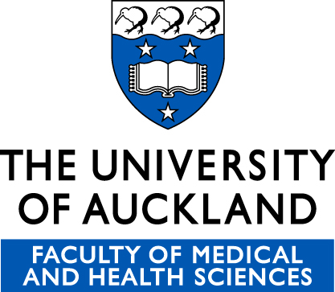

Participant information Sheet

Analysis of health benefits of Olive Leaf extract

Co-ordinating Investigator: Anna Boss
Masters Student
Biomedical Science
Tel. 0212021055
Email: aboss517@aucklanduni.ac.nz

Ethical Approval: Study reference – 15/NTB/27
This study has received ethical approval from the Ethics Committee on 23/02/15

About the Study:
You have been invited to take part in this study which will investigate the effect of a commercially available Olive leaf extract (OLE) supplement, to determine if this product changes gene regulation contributing to health benefits in people. The use of OLE in traditional medicine and a supplement has indicated benefits including cardiovascular health, immune function and insulin sensitivity.

What is the purpose of the study?
The results from this study will contribute to understanding how OLE benefits health and could improve health outcomes for the health of many people.
Olive leaf extract has been available in the market for years and is marketed as Olive Leaf Extract. The current OLE is sourced from Comvita.
The ingredients: each 15ml daily dose contains:
- Vegetable glycerol (bulking agent)
- Olea europaea (Olive) Leaf extract (water, olive leaf solids) equivalent to 7.5g

List component benefits:
- Traditionally used to support the immune system
- Contains 5 times the antioxidant activity of the equivalent amount of Vitamin C, delivering powerful free radical scavenging ability.
Recent literature has shown Comvita Olive Leaf extract to reduce blood pressure and improve insulin sensitivity.
Olive Leaf extract contains concentrated antioxidants. The supplement has been clinically tested and shown to help regulate blood sugar levels, blood pressure, and inflammation. It is a widely used supplement in traditional medicine. Health claims include increased satiety and improved immunity.
The success of this trial will be determined by measuring changes in gene regulation (by looking at expression levels of RNA from blood samples) with Olive leaf extract supplementation. These expression levels will be interpreted with relevance to health benefits. This will be explained in more detail by the investigators if required.
The Olive leaf extract will be compared to a placebo supplement that does not contain any of the active ingredients. The placebo will contain ingredients that will be similar to the OLE bitter flavor;
- 30L Sucrose octa acetate
- 98g Caramel colour
- 0.9g Damascenone
- 0.075g Guaiacol
- 0.075g Eugenol
Olive leaf extract and the placebo are in a liquid form and it will be recommended that two doses of 10ml be taken every day with 2 meals, preferably breakfast, lunch or dinner.
This is a double blinded, randomised, placebo controlled, parallel intervention trial that will last for 8 weeks.
Double blinded – neither the study participant nor the researchers of this trial will know what treatment (either OLE or the placebo) is being taken for the trial. The treatment will be revealed at the end of the trial by the Principal Investigator.
Randomised – participants will be randomly allocated either the placebo or intervention group
Placebo controlled – the effectiveness of olive leaf extract will be compared to a similar compound in this case a medium which will be the placebo supplement.

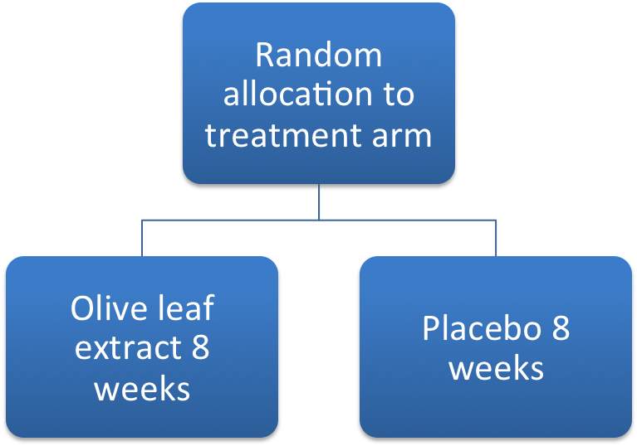

Inclusion into the study:
A total of up to 30 healthy candidates will be recruited from the Greater Auckland area, primarily through the pin up advertisements around the University.

You will be eligible for this trial if you are:
- Male
- Aged between 20 and 70 years
- Have no history of treatment for cancer in the previous 5 years, excluding non-melanoma skin cancers
- Have never smoked or have smoked relatively few cigarettes in the past (less than 10 pack per year)
- Any prescribed medication is stable (no changes in last 3 months)
- Have not taken antibiotics in the month prior to the study commences
- Are not on blood thinning medication (e.g. Aspirin)
- Are not currently taking any Vitamin D, fish oil/flax seed oil supplements, or eating more than 4 servings of oily fish (salmon, mackerel) each week.
- Able to attend local study centre at Grafton, Auckland for evaluation

What will my participation in the study involve?
Interested candidates will be given time to consider whether they wish to participate in the study and a consent form will be signed in front of one of the investigators if the candidate has decided to take part.

Inclusion into the study will be determined by each interested candidate completing a brief lifestyle and medical questionnaire (Eligibility Questionnaire) after consent to take part in the study has been given. This questionnaire can be either; posted, emailed or handed to you as you prefer. Based on this information inclusion into the study will be assessed. There will be 2 visits to the study centre at Grafton, Auckland.

Visit 1 (week 1). Base line information will be determined. Height and weight measures will be taken, along with a blood sample of up to 10-15 mls. Supplement oils for the 8 weeks of the trial will be provided, along with instructions for use. A quality of life questionnaire will be completed. An interview will be conducted to create an itemized food diary for 3 days previous to meeting (1 weekend day, 2 week days). A fecal sample will be taken from each participant, plastic containers will be provided.

Visit 2 (week 8) After the 8 week intervention height, weight will be measured as well as, blood sample (10-15ml)s collected. An itemized food diary for 3 days in the week will be completed. A fecal sample will be taken from each participant, plastic containers will be provided.

Study Questionnaires
Before starting the study, the researchers will go over each questionnaire to ensure you understand how they are to be completed, and to encourage completion of these.

Eligibility questionnaire

This questionnaire must be undertaken at the start of the trial after the consent has been given and will provide information that will ensure you meet all requirements for taking part. This questionnaire will take 5 – 10 minutes to complete.

What will happen with your blood?
RNA profiles will be analysed using a special technique (a transcriptome array) to understand gene expression.

In particular the researchers will not claim any right, ownership or property in your individual genetic information or that of your kinship group, hapu or iwi, Your consenting to participate in RNA sampling of the proposed study will not be construed as creating any right or claim on the part of the researcher to your genetic information”.

What are the possible benefits and risks of this study?

Study benefits:
There is no direct financial benefit to you by participation in this study and Olive Leaf extract will not be supplied after the study has been completed. However, the knowledge gained from participation in this study may benefit you and other people in the future, especially by providing information on the most appropriate and achievable dietary changes to benefit your health. Moreover, results may yield a profile for each participant that can give them an idea of how to improve their health.

Study Risks:
There is a minor risk of momentary discomfort, bruising, bleeding, swelling or (rarely) infection at the site of needle insertion for blood drawing. The OLE and placebo will have a bitter taste. The OLE can on the rare occasion cause bowel discomfort as it detoxifies, this should not last more than a few days but can include symptoms such as nausea, diarrhea and dizziness.

What if something goes wrong?

If you were injured as a result of treatment given as part of this study, which is unlikely, you won’t be eligible for compensation from ACC. However, compensation would be available from the study’s sponsor, Comvita, in line with industry guidelines. We can give you a copy of these guidelines if you wish. You would be able to take action through the courts if you disagreed with the amount of compensation provided.

If you have private health or life insurance, you may wish to check with your insurer that taking part in this study won’t affect your cover.

What are my rights?
Your participation in this study is entirely voluntary. If you do agree to take part we recognise your right to withdraw at any time or if you are unwilling to continue in the study without having to give a reason.
You have the right to access any information collected as part of this study

What happens after the study or if I change my mind?
Your participation in this study is entirely voluntary. If you do agree to take part we recognise your right to withdraw at any time or if you are unwilling to continue in the study without having to give a reason.

Olive Leaf extract will not be supplied after the study has been completed; it is available at most pharmacies or on the Comvita website at a cost to the participant.

Results:
There may be a delay between data collection and publication. You will be informed in writing of the results of the study. You will also be invited to any future seminars or presentations made on this study. You can be provided with an interpreter if needed. You may have a friend or family support to help you understand the risks and/or benefits of this study and any other explanation you may require.

Confidentiality of your records:
All information obtained from your participation in this study will be held strictly confidential. In addition to the health professionals caring for you, the researchers and your regional ethics committee may review your medical records. No material which could personally identify you will be used in any reports on this study. Your records will be stored confidentially under the direction of the researchers.

What happens to the remainder of your sample:
If there is any remainder of raw or processed blood or RNA the material may be used by the same research group to further this research area. If samples are requested for a new and independent study consent will be requested from participants. Fecal samples will be used for gut microflora profile analysis and surplus blood may be used to analyse hormone changes with supplementation of the Olive Leaf extract. The surplus material (blood, RNA or Fecal matter) will be destroyed at the end of ten years. The sample to be destroyed will be done so according to New Zealand and University of Auckland regulations for disposal of human blood and tissue, involving autoclaving of the sample before incineration. We assure your confidentiality with your genetic data and security on the material collected.

What happens to the information in the questionnaires?

Your food intake data from the 3 day itemized dietary log will be analysed to see if there are any foods you regularly eat that may impact on the intervention and results observed or that have changed because of the intervention. You will be excluded from the study if you are unable to provide food intake information either at the start or end of the trial. This information will be coded, so no personal details (specifically your name) will be made available to researchers.

Who do I contact for more information or if I have concerns?

Study Co-ordinator: Anna Boss
Biomedicine Masters Student
Tel. 0212021055
Email: aboss517@aucklanduni.ac.nz

Ethics Committee: Health and Disability Ethics Committees
Tel: 0800 4 ETHICS (438 442)
(from outside New Zealand: +64 4 819 6877)
hdecs@moh.govt.nz

If you have any queries or concerns regarding Maori issues related to this study you may wish to contact Associate Professor Papaarangi Reid, FMHS, UoA. Tel. 09-373 7599 x 84853, email: p.reid@auckland.ac.nz.

“This study (ethics reference 15/NTB/27) has received ethical approval from the xxx Regional Ethics Committee on 23/02/15

